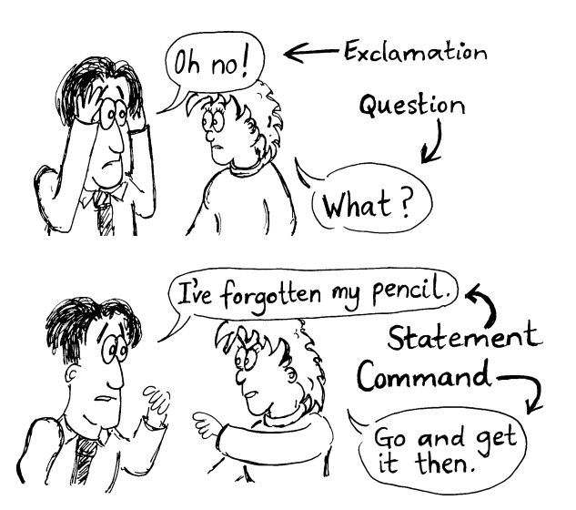
Types of sentences: statement, exclamation, question and command

1. Copy out the sentences below and write beside them what type of sentence they are.
(a) Have you been swimming?
(b) Go and get the work-bags.
(c) Oh no!
(d) The boy was running.
(e) He went to the shops.
(f) Can you think of another sentence?
(g) I don’t believe it!
(h) Put your chairs on the table.
2. Look through your reading book. Find one example (if you can) of:
(a) statements
(b) commands
(c) questions
(d) exclamations

3.Write down one example of your own…
(a) exclamations
(b) commands
(c) statements
(d) questions

4. Change these sentences into a different type of sentence.
(a) Get the ruler.
(b) Do dogs eat cornflakes?
(c) I’ve been an idiot!
(d) I am going to the shops.
(e) Can you pass me the ruler?

