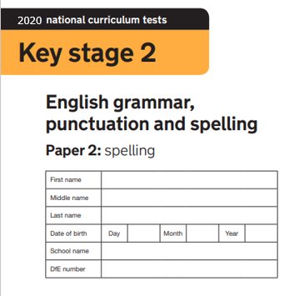
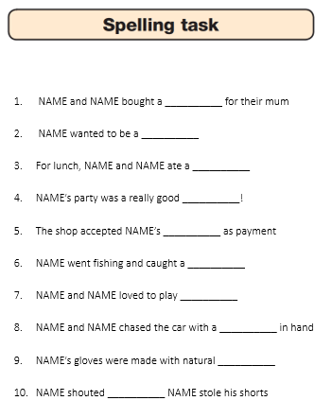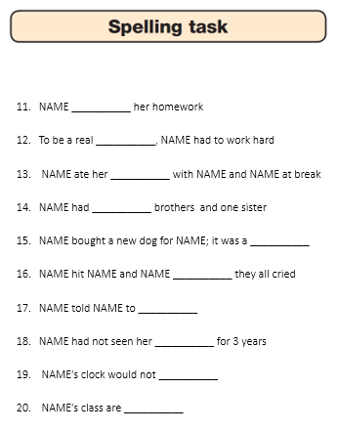
Pass the next page on to a sibling or adult to read to you. Then mark it and upload your score on to Seesaw!

Spelling 1  The word is chendaynor  NAME and NAME bought a chendaynor for their mum  The word is chendaynor  Spelling 2  The word is phaublasternaut  NAME wanted to be a phaublasternaut  The word is phaublasternaut  Spelling 3  The word is swintlefand  For lunch, NAME and NAME ate a swintlefand  The word is swintlefand  Spelling 4  The word is partee  NAME’s party was a really good partee!  The word is partee  Spelling 5  The word is jenjuvioucher  The shop accepted NAME’s jenjuvioucher as payment  The word is jenjuvioucher  Spelling 6  The word is traots  NAME went fishing and caught a traots  The word is traots  Spelling 7  The word is calllashmerinton  NAME and NAME loved to play calllashmerinton  The word is calllashmerinton  Spelling 8  The word is skeeparh  NAME and NAME chased the car with a skeeparh in hand  The word is skeeparh  Spelling 9  The word is flousifullaticals  NAME’s gloves were made with natural flousifullaticals  The word is flousifullaticals  Spelling 10  The word is becos  NAME shouted becos NAME stole his shorts  The word is flousifullaticals | Spelling 11  The word is reundertapulatted  NAME reundertapulatted her homework  The word is reundertapulatted  Spelling 12  The word is superjowluderon  To be a real superjowluderon, NAME had to work hard  The word is superjowluderon  Spelling 13  The word is jointiorio  NAME ate her jointiorio with NAME and NAME at break time  The word is jointiorio  Spelling 14  The word is free  NAME had free brothers and one sister  The word is free  Spelling 15  The word is hounderismontisaur  NAME bought a new dog for NAME; it was a hounderismontisaur  The word is hounderismontisaur  Spelling 16  The word is sowuh  NAME hit NAME and NAME sowuh they all cried  The word is sowuh  Spelling 17  The word is mbortinate  NAME told NAME to mbortinate  The word is mbortinate  Spelling 18  The word is antiaunty  NAME had not seen her auntiaunty for 3 years  The word is antiaunty  Spelling 19  The word is ticktockalocketock  NAME’s clock would not ticktockalocketock  The word is ticktockalocketock  Spelling 20  The word is awesomej (silent j)  NAME’s class are awesomej  The word is awesomej (silent j)

