Flatiron building

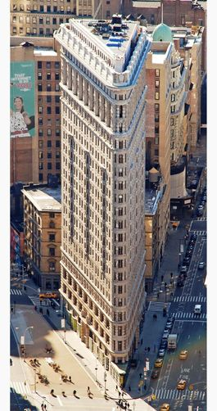

The Flatiron Building was originally called the Fuller Building. It was finished, in 1902 and it was one of the tallest buildings in the city. The building is triangular shaped. The name "Flatiron" is because it looks like an old-fashioned cast iron clothes iron. The building was designated a New York City landmark in 1966.

Central Park

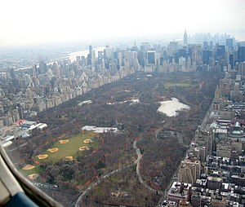

Central Park is a large park in New York City. It has about 35 million visitors every year and it is the most visited park in the USA. The park contains lakes, a castle, a museum and a zoo.

It is 4km long and 0.8km wide. It has 20 gates where you can enter the park.

Times Square

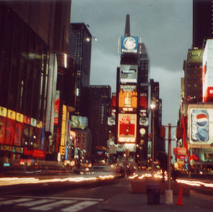

Times Square is a major centre for tourism, theatre and shopping. It is very busy with both people and traffic. It is named after the New York Times, which used to have its main building there. It also has a Subway station there and it is famous for New Year’s Eve ball drop.

Rockefeller Center

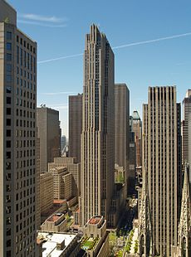

Rockefeller Center is a group of buildings covering 22 acres. The buildings are connected underground and an ice skating rink is located in the middle. It was built in 1939 by John D. Rockefeller Jr.

Statue of Liberty

The Statue of Liberty is on Liberty Island in New York Harbour. It used to welcome visitors travelling by ship. The statue was given to the USA by France to declare independence.

The statue is woman wearing a stola, crown, sandals and she has a torch in her raised right hand. The statue is made of copper and is 93 metres tall.

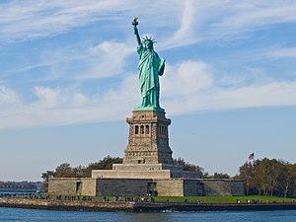

Brooklyn Bridge

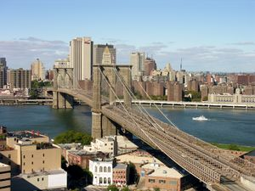

The Brooklyn Bridge is one of the oldest suspension bridges in the United States. It is 1,825 metres long. The bridge goes over the East River. It connects Manhattan and Brooklyn. It is one of the leading landmarks of New York City.

The bridge was built from 1869 to 1883. It was designed by John Roebling. When it was finished, it was the tallest structure in North America.

Empire State Building

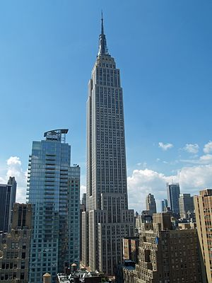

The Empire State Building is a skyscraper in New York City. It is 381 metres tall and has 103 floors. For 41 years, it was the tallest building in the world. It was built in 1931 and is one of the most famous landmarks in the USA.

Staten Island Ferry

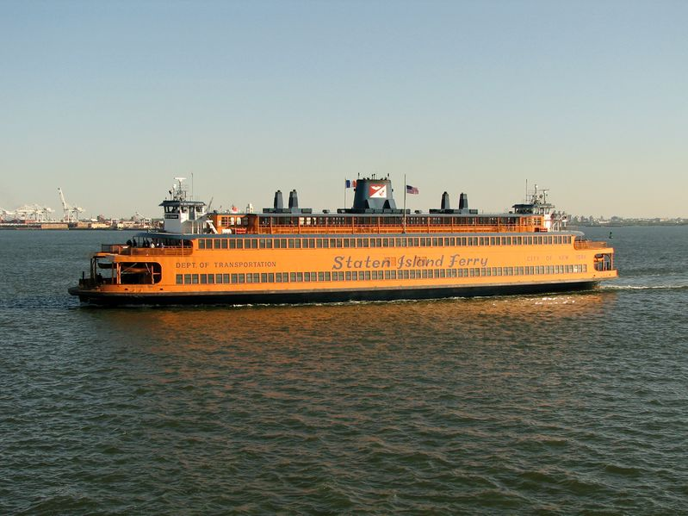

The Staten Island Ferry is a free ferry service that runs between Staten Island and Manhattan. It started in 1817. The trip takes around 25 minutes and it runs 24 hours a day, 365 days a year.

The ferry carries bicycles, as well as people. Over 21 million people ride the Staten Island Ferry a year.

Chrysler Building

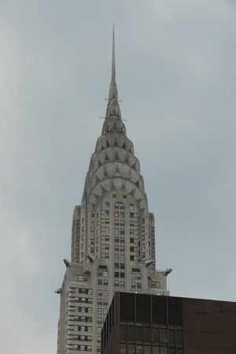

The Chrysler Building is a skyscraper in New York City. It is 319 metres tall and has 77 floors. It was built in 1931 and is one of the tallest buildings in the world. The Chrysler Building is still the tallest brick building in the world. It was completed in 1930.

Chelsea Market

Chelsea Market is an indoor market with more than 35 stalls. These stalls sell food such as. soup, nuts, wine, coffee, cheese and cheesecake. It gets 6 million visitors every year.

