UK Bridges
Read the information on this famous UK bridges. The same as the task you completed on UK Castles (plotting them on a map), can you place these bridges on a map. You can use the same map as your castles or you can use another blank one. There are some extra challenges on the other page as well.

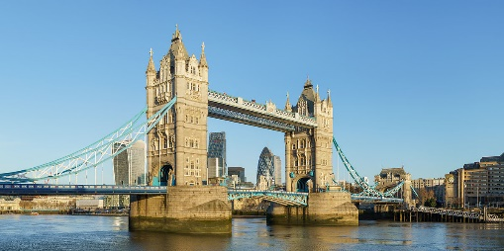
Tower Bridge
Where is it?: London
How long is it?: 244m
Type of bridge: Suspension bridge

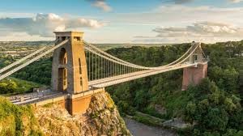
Clifton Suspension Bridge
Where is it?: Bristol
How long is it?: 412m
Type of bridge: Suspension bridge

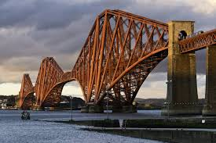
Forth Bridge
Where is it?: Edinburgh (10 miles outside)
How long is it?: 2400m
Type of bridge: Cantilever bridge

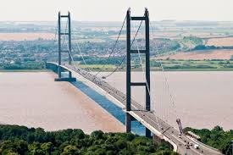
Humber Bridge
Where is it?: Hull
How long is it?: 2200m
Type of bridge: Suspension bridge

Extra challenges
1) Could you find the name of the bridge in these cities and then place them on the map?
- Nottingham
- Newcastle
- Liverpool
- Cambridge

2) What are the different types of bridge?
- Suspension bridge
- Cantilever bridge
-
-
-
-
-

