Writing your own version of ‘Three Billy Goats Gruff’

You have read the story and answered questions on it. You have retold the story using sequencing cards. You have used adjectives to describe the goats and the troll. Now we want you to bring all of this together to write your own version of the story.
Make sure:
- You use the adjectives to make your reader interested and engaged (it also helps to imagine what is happening).
- You have used capital letters and full stops in your sentences.
- Your story is the same structure as the original

- Goats arrive at the bridge
- They take it in turns to cross the bridge
- The troll ends up in the water
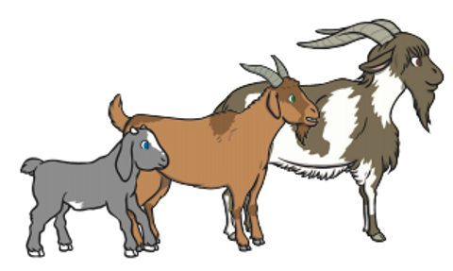
- The goats carry on their way

